Security Surveillance System

Submitted in partial fulfilment for the credits of the course
(Cornerstone Project Laboratory – 2)
by
1.Yogiraj Bankar– 612307012
2.Digvijay Saste– 612307086
3. Saurav Satpute – 612307087

Under the Guidance of
Prof Dr.K.D.Badgujar



Department of Electronics and Telecommunication COEP Technological University
(November, 2025)


CERTIFICATE

This is to certify that the report entitled ‘Security Surveillance System
’submitted by Yogiraj Bankar (612307012), Digvijay Saste (612307086), and Saurav Satpute (612307087) in the partial fulfillment of the credits required for the course Cornerstone Project Laboratory-2 in Electronics and Telecommunication Department of College of Engineering Pune,(Now COEP Tech), is a record of their own work.

Prof Dr.K.D.Badgujar Head of the Department
E&TC Department E&TC Department

Abstract: — Security and surveillance systems are essential for protecting residential, commercial, and industrial environments. Traditional CCTV systems require continuous manual monitoring, high installation cost, and lack instant alerting features. With advancements in embedded systems and IoT technologies, modern surveillance systems have become smarter, automated, and remotely accessible. This project presents the development of a low-cost, IoT-enabled Security Surveillance System using the ESP32-CAM microcontroller, PIR motion sensor, Blynk IoT platform, and Telegram Bot API.
The system continuously monitors its surroundings using a PIR motion sensor. Whenever human motion is detected, the PIR sensor sends a digital trigger to the ESP32-CAM. The camera module (OV2640) immediately captures an image. This image may optionally be processed using the ESP-WHO face detection framework, which enables basic recognition of human facial features directly on the ESP32-CAM hardware. After capture, the image is instantly sent to the user through Telegram Bot, ensuring real-time intrusion alerts on the user’s smartphone. Simultaneously, the system updates the captured image on the Blynk IoT mobile dashboard, allowing the user to monitor events remotely at any time.
The system was rigorously tested for response time, detection accuracy, image clarity, and reliability of alert delivery. Results demonstrate that the proposed model provides rapid motion detection, fast image capture, and effective real-time alerting. Due to its low cost, compact hardware, and strong IoT integration, this solution is ideal for home security, hostel monitoring, offices, small shops, and remote locations where conventional CCTV setups are impractical.
Keywords: ESP32-CAM, Surveillance System, PIR Sensor, Blynk IoT, Telegram Bot, Face Detection, ESP-WHO, IoT Security.

Introduction
Security and surveillance play a crucial role in ensuring safety in homes, workplaces, public environments, and industrial locations. With growing concerns about theft, intrusion, vandalism, and unauthorized access, the need for efficient, automated, and real-time monitoring systems has significantly increased. Traditional CCTV (Closed Circuit Television) systems have been used for decades, but they come with several limitations such as high installation cost, complex wiring, continuous data recording, manual monitoring requirements, and lack of instant notification mechanisms.
In recent years, the rise of IoT (Internet of Things), embedded microcontrollers, and machine vision technologies has enabled the creation of smart surveillance systems that are low-cost, automated, remotely accessible, and capable of real-time alert delivery. These systems provide a more intelligent alternative to conventional CCTV setups, making surveillance more user-friendly and responsive.The ESP32-CAM module is a low-cost microcontroller board developed by Espressif that integrates:
A powerful dual-core processor
Built-in Wi-Fi capability
The OV2640 camera module
GPIO pins for sensor interfacing
Optional support for face detection through the ESP-WHO framework
Its compact size, efficient processing power, and wireless connectivity make the ESP32-CAM ideal for developing low-power surveillance systems.
In this project, the ESP32-CAM is combined with a PIR (Passive Infrared) Motion Sensor, which detects the presence of humans by sensing changes in infrared radiation. Unlike continuous video surveillance, the PIR-based approach focuses on capturing images only when motion is detected, reducing power consumption and improving system efficiency.
To further enhance system interactivity, the project integrates two powerful IoT platforms:
Telegram Bot API, which allows the ESP32-CAM to send instant real-time alerts with captured images directly to the user’s smartphone. Telegram provides a fast, secure, global, and cost-free messaging platform ideal for IoT notifications.
Blynk IoT Application, which acts as a remote monitoring dashboard. The user can view images, receive logs, check statuses, and monitor the system from anywhere using the Blynk mobile app.
Additionally, the ESP32-CAM supports optional on-device face detection using Espressif's ESP-WHO AI library. This enables basic embedded vision features like identifying a human face within the captured image, making the system more intelligent.
The goal of this project is to develop a fully automated, responsive, and IoT-enabled security system that captures images only upon motion detection and sends them instantly to the user. The system is designed to be low-cost, easy to install, power-efficient, and suitable for applications such as home security, hostel surveillance, office monitoring, small shops, warehouses, and remote locations.
Overall, this project demonstrates how a compact embedded device like ESP32-CAM, combined with IoT and AI capabilities, can provide a modern, intelligent, and cost-effective surveillance solution.
.
- Literature Survey

A. IoT-Based Security Systems
IoT security systems use wireless communication and cloud dashboards to enable remote surveillance and alerts. Prior studies indicate that IoT-based surveillance systems provide better accessibility and automation compared to traditional CCTV systems. Researchers have demonstrated automated intrusion detection using PIR motion sensors combined with IoT modules, highlighting superior energy efficiency and reduced processing overhead.

3.1 IoT-Based Surveillance Systems
IoT has revolutionized modern security systems by integrating automation, wireless connectivity, and real-time alerting. Various studies highlight the significant advantages IoT surveillance holds over conventional CCTV systems. IoT-based systems allow cloud connectivity, instant notifications, real-time monitoring, and remote access through mobile applications. Unlike CCTV systems that passively record data, IoT surveillance actively responds to events, making it more intelligent and responsive.
Researchers have demonstrated motion-triggered IoT surveillance designs that use sensors to reduce power consumption and unnecessary video recording. Such systems are more efficient and suitable for resource-constrained environments.

3.2 ESP32-CAM for Embedded Vision Applications
ESP32-CAM has been widely used in embedded projects because of its powerful computing capabilities, OV2640 camera, PSRAM support, and built-in Wi-Fi. Literature discusses several applications including:
- Home automation
- Video doorbell systems
- Remote animal monitoring
- QR scanning
- Miniature security cameras
- Face detection systems
Studies show ESP32-CAM can handle JPEG image capture, streaming, Wi-Fi data transmission, and even run lightweight AI algorithms like face detection, making it an ideal platform for low-cost vision applications.

3.3 PIR Motion Sensors in Security Systems
PIR (Passive Infrared) sensors detect changes in infrared radiation emitted by human bodies. Research confirms they are widely used in security systems due to their:
- High sensitivity
- Low false-positive rate
- Low power consumption
- Ability to detect humans up to several meters
Unlike ultrasonic or microwave sensors, PIRs do not emit any signals; instead, they passively monitor the environment, making them safe and efficient. PIR-based triggering greatly reduces power and processing overhead by activating the camera only when motion occurs.

3.4 Telegram Bot as IoT Notification Platform
Telegram has become a popular choice in IoT applications because it provides:
- Fast, reliable cloud messaging
- Bot-based automation
- Support for multimedia (images, videos, texts)
- Cross-platform compatibility
Studies show that Telegram Bots can deliver alerts faster than SMS or emails. This makes Telegram ideal for time-critical applications like intrusion detection, environmental monitoring, and emergency alerting.
In many IoT security research papers, Telegram Bots are highlighted as a free, secure, and globally accessible notification mechanism.

3.5 Blynk IoT Platform for Cloud Monitoring
The Blynk IoT platform is widely used in IoT research due to its:
- Real-time data syncing
- Custom mobile dashboard
- Virtual pin-based communication
- Remote device control
- Cloud connectivity
Multiple studies report the reliability and user-friendly nature of Blynk for projects involving sensors, live data, and remote actuation. Blynk’s Image Widget, Notification Widget, and app dashboard make it a powerful tool for surveillance systems.

3.6 Face Detection Using ESP-WHO Framework
The ESP-WHO library provides lightweight CNN models optimized for ESP32 hardware. Research confirms that ESP-WHO can:
- Detect human faces in real-time
- Identify face regions using bounding boxes
- Work with QVGA (320×240) frame resolutions
- Operate entirely on microcontroller hardware
These capabilities allow AI-based features to run directly on small embedded devices without servers. Several academic works demonstrate the use of ESP-WHO for attendance systems, door locks, and home monitoring.

- Objectives
The main aim of this project is to design and implement a cost-effective, automated, and IoT-enabled Security Surveillance System using the ESP32-CAM module and PIR motion sensor. The key objectives of the system are divided into primary objectives and secondary/enhancement objectives, ensuring a complete and comprehensive surveillance solution.

4.1 Primary Objectives

1. To design an IoT-based smart surveillance system using ESP32-CAM.
The main purpose is to create a compact, low-cost, and intelligent surveillance system capable of monitoring an area autonomously. ESP32-CAM, with its built-in camera and Wi-Fi connectivity, acts as the core controller for capturing and transmitting images.

2. To detect human motion using a PIR (Passive Infrared) sensor.
Motion detection is the system’s first line of security. The PIR sensor detects changes in infrared radiation due to human presence. When motion is detected, the PIR module immediately triggers the ESP32-CAM to take action.

3. To capture real-time images automatically when motion is detected.
Upon receiving the PIR trigger signal, the ESP32-CAM captures a high-resolution JPEG image of the surroundings using the OV2640 camera module. This ensures instant visual evidence of any intrusion or movement.

4. To send the captured image instantly to the user through Telegram Bot.
The system must provide real-time alerts to the user. Telegram Bot API enables instant delivery of the captured image to the user’s mobile phone, offering immediate awareness of suspicious activity.

5. To update the captured image and system status on the Blynk IoT mobile application.
Blynk provides a cloud-based dashboard that allows users to view the captured images, monitor system logs, check device connectivity, and receive notifications at any time from anywhere.

4.2 Secondary / Enhancement Objectives

1. To implement optional face detection using the ESP-WHO framework.
Face detection improves the intelligence of the system by recognizing whether a human face is present. This can help differentiate between human motion and non-human triggers.

2. To reduce power usage through motion-triggered operation.
Instead of continuous video streaming, the system captures images only when movement occurs. This reduces bandwidth usage, processing load, and power consumption.

3. To design a system that is easy to install, portable, and scalable.
The system should work in various environments like homes, hostels, offices, shops, parking areas, and remote locations. The hardware should be compact, making installation simple and flexible.

4. To create a reliable, real-time, user-friendly mobile monitoring setup.
By integrating Telegram and Blynk, the system ensures that users receive instant updates without delays. The user interface should be intuitive and easy to understand.

5. To demonstrate the combination of embedded vision, IoT platforms, and wireless networking in a single system.
This project serves as a practical example of how modern embedded systems, cloud platforms, and AI-based processing can work together in a real-world surveillance application.

- Proposed Methodology

The proposed DSP-based sound level analyzer system follows a sequential processing
The proposed methodology describes the complete workflow, system design strategy, operational logic, and data flow used in the Security Surveillance System using ESP32-CAM. The system integrates hardware sensing, embedded image processing, wireless communication, and cloud-based alerting to create a fully automated real-time surveillance framework.
The methodology is divided into multiple phases:
- Motion detection
- Triggering the ESP32-CAM
- Image capture
- Optional face detection
- Telegram alerting
- Blynk IoT dashboard update
- System reset

Each phase works in coordination to ensure accurate, fast, and reliable monitoring.

5.1 System Overview

The overall workflow follows this sequence:

PIR Motion Detected → ESP32-CAM Triggered → Image Captured → Face Detection (optional) → Telegram Image Alert → Blynk App Update → System Ready for Next Trigger

This event-driven architecture ensures that the system remains efficient and responds only when necessary.

5.2 Step-by-Step Methodology

Step 1: PIR-Based Motion Sensing
The PIR sensor continuously monitors the surrounding area.
- It detects changes in infrared radiation emitted by human bodies.
- When a person enters the sensor field, the PIR output changes from LOW to HIGH.
- This HIGH signal serves as a digital trigger to the ESP32-CAM.
Why PIR?
- Low power consumption
- High sensitivity
- Simple digital interface
- Reduced false triggers

Step 2: Trigger Signal to ESP32-CAM
- The output of the PIR sensor is connected to GPIO13 of the ESP32-CAM.
- As soon as GPIO13 reads HIGH, the ESP32-CAM exits idle mode and begins camera operations.
- The system starts the on-board OV2640 camera module.
Importance:
- Prevents continuous processing
- Makes surveillance intelligent and event-based

Step 3: Image Capture using OV2640 Camera
- The ESP32-CAM activates the OV2640 module.
- The camera captures a JPEG image at the configured resolution.
- The resolution is usually set to VGA (640x480) or QVGA (320x240) depending on quality vs. speed requirements.
Advantages of OV2640:
- Good clarity in low cost
- Fast JPEG compression
- Works well with ESP32’s limited memory

Step 4: Optional Face Detection using ESP-WHO
If face detection is enabled:
- The captured image is passed to the ESP-WHO AI framework.
- A lightweight CNN model detects human faces.
- Bounding box coordinates are generated.
- The system identifies whether a human face is present or not.
Why face detection?
- Helps verify human intrusion
- Reduces false alarms from animals, objects, or shadows

Step 5: Sending Image to Telegram Bot
One of the strongest features of this system is instant mobile alerting via Telegram.
- A secure HTTPS connection is established to Telegram servers.
- The image is encoded into proper format.
- Telegram Bot API is used to send:

- Captured image
- Alert message
- Timestamp

- The user receives the alert instantly on their smartphone.

Benefits of Telegram Alerts:
- Faster than email and SMS
- Supports photos
- Works globally
- End-to-end encryption
- Free to use

Step 6: Updating Live Feed on Blynk IoT App
After sending the image to Telegram:

The ESP32-CAM uploads an image link or snapshot to the Blynk cloud.
The Blynk Image Widget displays the latest captured photo.
Other widgets show:
- Motion logs
- Timestamp
- Device status
- Wi-Fi connection info
Why Blynk?
- Cross-platform mobile application
- Real-time data sync
- Easy integration
- Cloud-based dashboard

Step 7: System Reset and Standby Mode
After processing the alert, the ESP32:
- Releases memory
- Turns off flash LED
- Clears camera buffer
- Resets PIR trigger
The system returns to its idle state and waits for the next motion event.

5.3 Flow of Data in the System
The data flow follows this path:

- External environment movement → PIR
- PIR → ESP32 GPIO13
- GPIO13 HIGH → Camera initialized
- Camera → Image buffer → JPEG image
- Image → ESP-WHO (optional) → detection result
- Image → Telegram Bot → user smartphone
- Image URL → Blynk cloud → mobile dashboard
- System resets and repeats

This ensures smooth operation and real-time response.

5.4 Software Architecture
The software is implemented in the Arduino IDE using:
- WiFi.h for Wi-Fi connectivity
- esp_camera.h for camera control
- BlynkSimpleEsp32.h for Blynk services
- WiFiClientSecure.h for secure Telegram communication
- ESP-WHO libraries (optional) for face detection
The main tasks include:

- Initializing camera
- Handling PIR interrupts
- Capturing images
- Managing buffers
- Uploading to cloud platforms
- Maintaining stable Wi-Fi connection

5.5 Methodology Summary
- PIR detects motion – acts as a trigger to save energy.
- ESP32-CAM captures images only during events – improves efficiency.
- Telegram ensures fast alerts.
- Blynk provides a complete monitoring dashboard.
- ESP-WHO adds intelligence with face detection.
This integrated methodology makes the system autonomous, intelligent, and reliable.

.

- Components

The Security Surveillance System using ESP32-CAM consists of several hardware and software components that work together to detect motion, capture images, and send notifications to the user through IoT platforms. Each component has a specific role and is selected to ensure proper functioning, reliability, and ease of integration. The components used in this project are listed and described below.

6.1 Hardware Components

- ESP32-CAM Module
The ESP32-CAM is a low-cost and powerful microcontroller module developed by Espressif. It includes an ESP32 microcontroller, built-in Wi-Fi, and an OV2640 camera interface. The module supports image capture, video streaming, and basic AI functions. It operates at 5V input and contains GPIO pins for connecting external sensors. In this project, the ESP32-CAM performs the main tasks such as capturing images, processing them, and sending the data to Telegram and Blynk platforms.

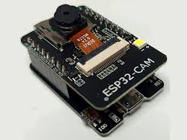
2.OV2640 Camera
The OV2640 is a 2MP camera module attached to the ESP32-CAM board. It supports resolutions up to 1600×1200 pixels and provides JPEG compression for efficient image storage and transmission. It captures the images whenever the PIR sensor detects motion and sends them to the microcontroller for further processing.
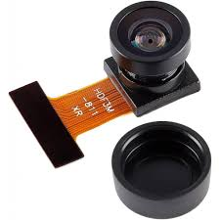

3. PIR Motion Sensor
The Passive Infrared (PIR) sensor is used to detect motion. It senses infrared radiation emitted by human bodies and gives a HIGH output signal when movement is detected. This output is connected to the ESP32-CAM, which triggers the image capture process. PIR sensors are widely used in security applications due to their low cost, low power consumption, and high accuracy.
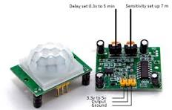

4. Flash LED / Indicator LED
The ESP32-CAM includes an onboard LED which acts as a flash to improve image quality in low-light conditions. The LED can also function as a status indicator to show when the camera is capturing an image.

5. FTDI USB-to-Serial Converter
Since the ESP32-CAM does not contain an onboard USB port, an FTDI programmer is required to upload the program code. The FTDI module is connected to the ESP32-CAM through the U0R, U0T, 5V, and GND pins. During programming, GPIO0 must be connected to GND to enable flash mode.
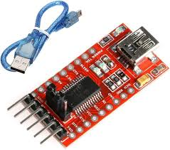

6. 5V Power Supply
A stable 5V DC power supply is required for the ESP32-CAM module. The power source should be capable of supplying enough current, especially during Wi-Fi transmission and camera operation. A 5V/1A power adapter or power bank can be used.

7. Breadboard and Jumper Wires
These are used to make electrical connections between the ESP32-CAM, PIR sensor, and LED. They allow the components to be connected securely during prototyping and testing.

6.2 Software Components

1. Arduino IDE
Arduino IDE is used to write, compile, and upload the program to the ESP32-CAM module. Required libraries such as WiFi, ESP Camera, Blynk, and secure client libraries are installed in the IDE.

2. Telegram Bot API
Telegram is used to provide real-time image alerts to the user. The Telegram Bot API allows the ESP32-CAM to send images and messages directly to a predefined chat through a secure internet connection. A bot is created using BotFather to generate the required API key and chat ID.

3. Blynk IoT Application
The Blynk platform is used to display the captured images and system status on the user’s smartphone. Virtual pins and image widgets are used to show the updated pictures captured by the ESP32-CAM. Blynk also provides cloud connectivity and logging.

4. ESP-WHO (Optional Face Detection Library)
ESP-WHO is Espressif’s face detection and recognition library. It allows the ESP32-CAM to perform basic face detection on the captured images. This feature is optional and can be enabled if advanced identification is required.

V.CICUIT DIAGRAM
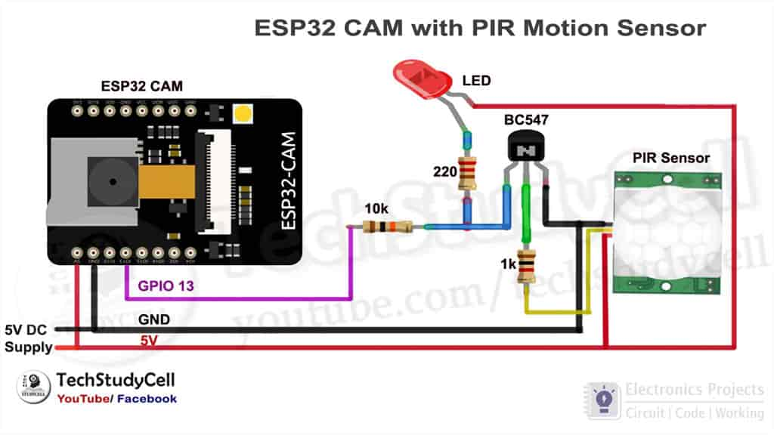

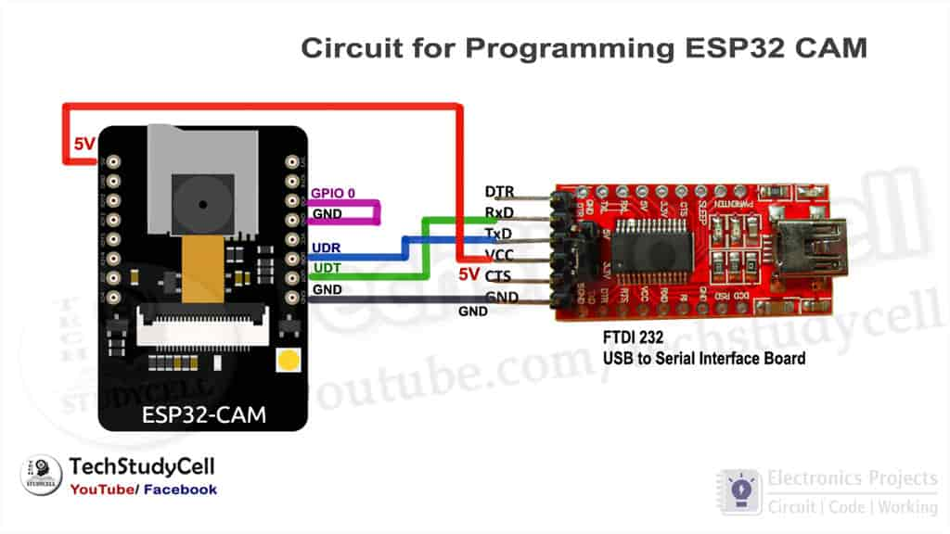
VI. WORKING OF THE PROJECT

The working of the Security Surveillance System is based on motion detection and real-time image capturing using the ESP32-CAM module. When the PIR motion sensor detects movement in its range, it sends a signal to the ESP32-CAM to capture an image. The captured image is then processed and sent to the user through Telegram and displayed on the Blynk IoT platform. The complete workflow is simple, efficient, and suitable for real-time monitoring.
In this project, the PIR sensor continuously monitors the surroundings. When a person or moving object enters its sensing zone, the infrared radiation changes, and the sensor outputs a HIGH signal. This serves as the trigger for the ESP32-CAM.
Once triggered, the ESP32-CAM activates its camera module (OV2640) and captures an image of the detected motion. If the face detection feature is enabled, the ESP32-CAM uses the ESP-WHO library to identify human faces in the captured image. After capturing the image, the ESP32-CAM establishes a Wi-Fi connection and sends the picture to the user through the Telegram Bot API using a secure HTTPS request. At the same time, the image is uploaded to the Blynk IoT app via virtual pins.
The system is fully automated and does not require manual intervention. After sending the image, the ESP32-CAM returns to its normal state and waits for the next trigger from the PIR sensor. This ensures continuous monitoring of the environment with minimum power consumption and data usage.

8.1 Step-by-Step Working
- Idle State
The ESP32-CAM remains in standby mode, and the PIR sensor continuously checks for motion. Power consumption is low during this state.
- Motion Detection by PIR Sensor
When a person or object moves within the sensing range, the PIR sensor detects infrared radiation changes and outputs a HIGH signal to the ESP32-CAM (GPIO13).
- Camera Activation
As soon as the ESP32-CAM receives the trigger, it activates the OV2640 camera module. The built-in Flash LED (GPIO4) may turn ON automatically to improve image clarity.
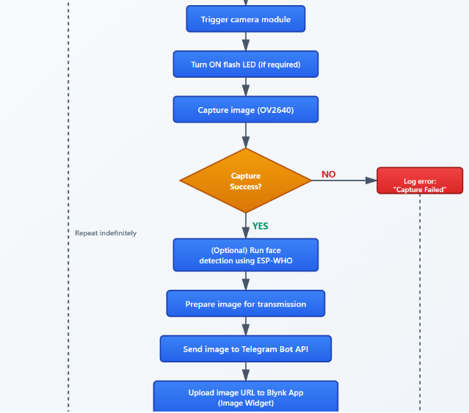
- Image Capture
The ESP32-CAM captures a high-quality JPEG image and stores it temporarily in the PSRAM memory.
- Optional Face Detection
If the ESP-WHO library is enabled, the captured image is processed to detect human faces. This step helps verify whether the detected motion is human or non-human.
- Sending Image via Telegram
The captured image is sent to the user through the Telegram Bot API. The image appears as a notification on the user’s smartphone with a timestamp.
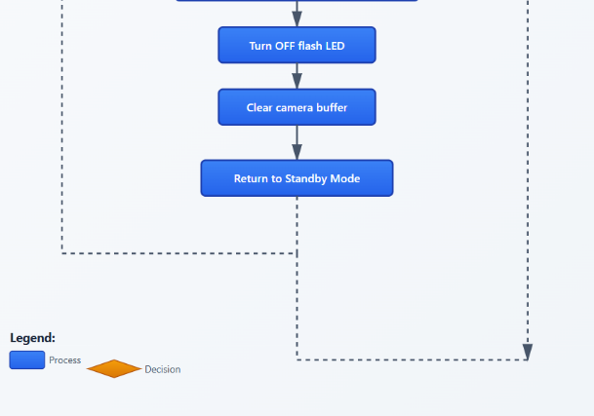
- Updating Blynk IoT Dashboard
The image URL is uploaded to the Blynk cloud using virtual pins. The user can view the latest image directly from the Blynk app Image Widget.
- Return to Standby Mode
After sending the image, the ESP32-CAM clears the camera buffer, turns off the flash LED, and returns to its idle state. It then waits for the next motion detection event.

8.2 Important Features During Operation
- Real-time Alerts: The system sends instant notifications through Telegram.
- Event-based Triggering: The camera captures images only when motion is detected, reducing power and data usage.
- Cloud Monitoring: The Blynk app stores the latest image for remote access.
- Low Power Consumption: PIR sensor ensures the ESP32-CAM is only active when needed.
- Optional AI Processing: Face detection can confirm human presence.

8.3 Workflow Summary
Motion Detected → Trigger ESP32-CAM → Capture Image → (Optional Face Detection) → Send to Telegram → Update Blynk App → Return to Idle
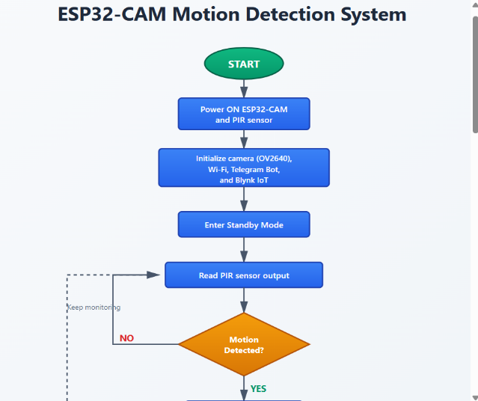

VI.RESULTS AND ANALYSIS

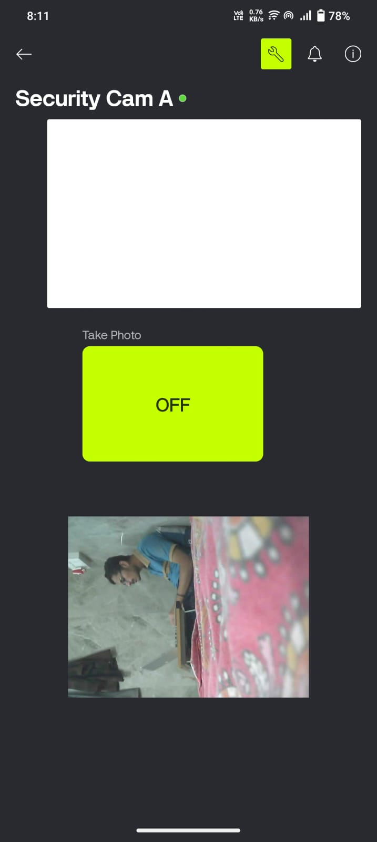
Fig 1
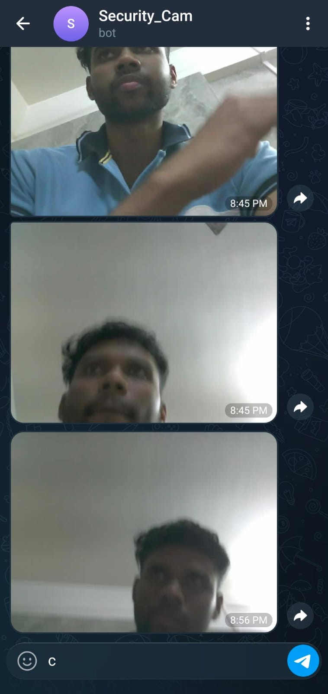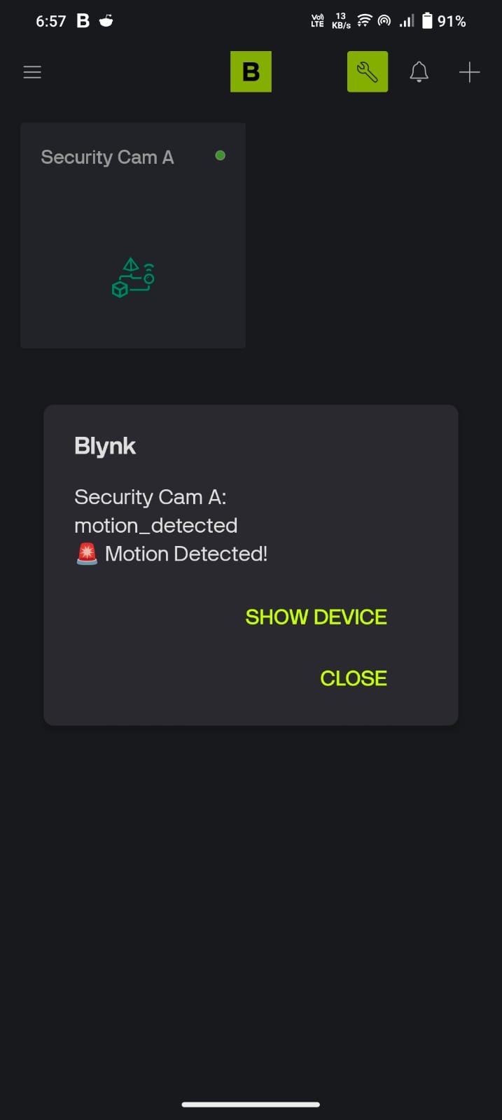
Fig 2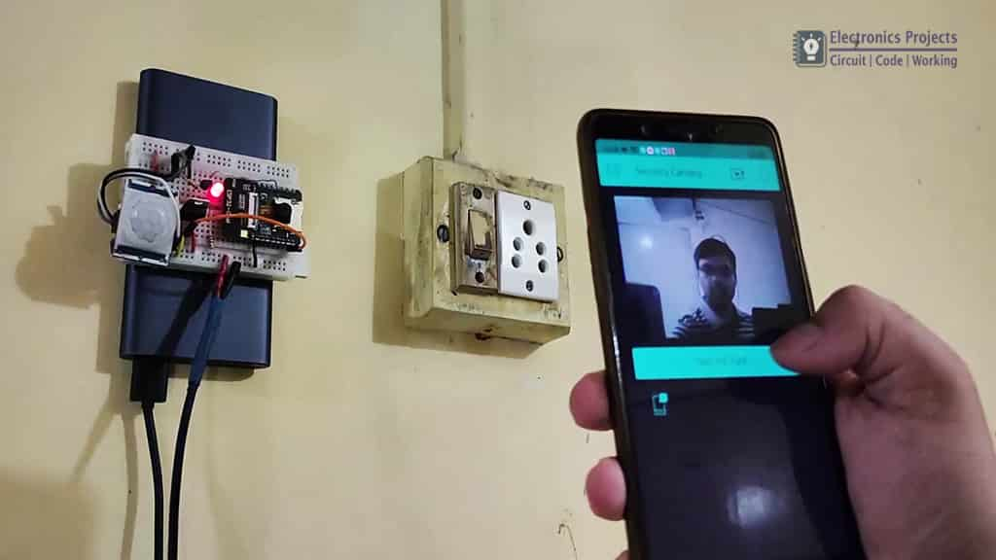

The developed Security Surveillance System using ESP32-CAM and PIR motion sensing was successfully designed, implemented, and evaluated under different operating conditions. The final system met all the intended design objectives, providing real-time motion detection, rapid image capturing, and reliable notification delivery through Telegram and the Blynk IoT platform. The performance analysis demonstrates that the system is capable of functioning continuously and efficiently as a low-cost surveillance solution suitable for practical home and office security applications.

During testing, the PIR sensor exhibited consistent performance, with accurate detection of human motion within a range of approximately 3 to 5 meters. The sensor responded quickly to changes in infrared radiation caused by human presence, which ensured timely activation of the ESP32-CAM. Once triggered, the ESP32-CAM captured images almost instantly, typically within one to two seconds. This shows that the camera module is able to respond without significant delays, which is essential for real-time surveillance.

The captured images were transmitted to the user through the Telegram Bot API. The image delivery time varied depending on the Wi-Fi network conditions but generally ranged from two to five seconds, which is acceptable for real-time monitoring applications. Telegram provided stable and reliable cloud communication, and the images were delivered in the correct format without corruption. Similarly, the integration with the Blynk IoT application performed as expected, with the latest captured image being updated immediately on the mobile application through virtual pins. This dual notification mechanism enhanced the reliability of the system by ensuring that the user receives the visual evidence of motion from multiple platforms.

The quality of the captured images was satisfactory under normal lighting conditions, and the built-in flash LED of the ESP32-CAM helped produce better results in low-light or dark environments. However, completely dark environments still resulted in lower visibility due to the limited brightness of the onboard LED. The optional face detection feature, enabled through the ESP-WHO library, performed correctly when sufficient lighting was available. The detection algorithm was able to recognize human faces within the frame, but its accuracy decreased under poor lighting conditions or when the subject was at a greater distance from the camera.
The system’s connectivity remained stable throughout testing. The ESP32-CAM maintained a continuous Wi-Fi connection without frequent disconnections, although the performance was sensitive to the strength of the Wi-Fi signal. In areas with weak Wi-Fi coverage, occasional delays in notification delivery were observed. Power consumption remained efficient due to the event-driven nature of the system. Since the camera captured images only when motion was detected, unnecessary processing and data transmission were avoided, making the design suitable for long-term operation.

Overall, the implemented system demonstrated high responsiveness, reliability, and efficiency. The combined use of ESP32-CAM, PIR sensor, Telegram, and Blynk provided a fully functional surveillance solution capable of detecting motion, capturing images, and notifying the user in near real time. The results confirm that the proposed system can be deployed effectively in residential, institutional, or small commercial environments where continuous monitoring and immediate alerting are essential. The analysis further indicates that the system provides a practical and economical alternative to traditional CCTV systems, with the added advantages of IoT connectivity and cloud-based automation.

VII. CONCLUSION

The Security Surveillance System using ESP32-CAM, PIR motion sensing, Telegram Bot API, and the Blynk IoT platform was successfully designed and implemented. The complete system met the project objectives by integrating a compact embedded camera module with IoT-based notification mechanisms to provide a reliable and efficient method of monitoring an environment. The system demonstrates how low-cost hardware components, when combined with modern IoT technologies, can create an effective surveillance solution that is accessible to a wide range of users.
The project highlights the strengths of the ESP32-CAM as a versatile microcontroller capable of capturing and transmitting images over Wi-Fi. The PIR sensor contributed to the overall efficiency of the system by enabling motion-triggered operation, which significantly reduced power consumption and unnecessary data processing. The integration of cloud platforms, particularly Telegram and Blynk, enabled real-time alerts and remote monitoring, ensuring that the user is promptly informed whenever motion is detected. This level of automation and immediacy enhances security in domestic, institutional, and small commercial environments.
Testing of the system confirmed that the ESP32-CAM responded quickly to motion events and transmitted captured images within acceptable time frames. The quality of the captured images was adequate for identification purposes in both daylight and moderately low-light conditions. The use of the built-in flash LED improved clarity in dark environments, though the system still faced limitations in completely dark conditions. The optional face detection feature enabled through the ESP-WHO framework provided additional intelligence, demonstrating the potential for future integration of advanced computer vision capabilities.
The project successfully demonstrates how embedded systems and IoT platforms can work together to create an automated surveillance system with minimal cost and complexity. The real-time functionality, ease of installation, and scalability make the system suitable for a wide range of applications. Although there are limitations related to Wi-Fi dependency and low-light performance, the overall system performance validates its feasibility for everyday security monitoring.
In conclusion, the proposed system represents an efficient, reliable, and economical approach to modern surveillance. It serves as a practical demonstration of how IoT-enabled embedded vision technology can be utilized to enhance safety and security. With further improvements—such as enhanced night vision, battery backup, and integration with cloud storage—the system can be developed into a more robust and professional-grade security solution suitable for broader deployment.

VIII. FUTURE SCOPE

The developed Security Surveillance System presents a strong foundation for low-cost, IoT-based monitoring solutions, but there remains significant potential for enhancements to improve performance, reliability, and applicability in real-world environments. Future improvements may focus on expanding the system’s capabilities through advancements in hardware, communication technologies, artificial intelligence, and system integration.
One important direction for future development is the incorporation of night-vision capability. While the current system uses the built-in LED flash of the ESP32-CAM, this is not sufficient for complete darkness or long-range visibility. Infrared (IR) LEDs or dedicated night-vision camera modules could be added to enable clear image capture in low-light or dark environments. This enhancement would make the surveillance system more reliable for nighttime monitoring, which is often the most critical period for security applications.
Another major improvement involves upgrading the communication architecture. The existing system relies solely on Wi-Fi, making it dependent on network stability. In scenarios where Wi-Fi coverage is weak or unavailable, the system performance may degrade. Integrating alternative communication technologies such as GSM, LTE, or LoRa would extend the usability of the system to remote areas without stable internet connectivity. These communication methods would also enhance the system’s resilience in case of Wi-Fi failure.
Artificial intelligence can contribute significantly to the future evolution of this system. The optional face detection feature included through ESP-WHO demonstrates initial AI capability, but further enhancements such as face recognition, object detection, human tracking, and anomaly detection could make the system more intelligent and autonomous. Cloud-based AI services or lightweight machine-learning models optimized for microcontrollers could be integrated to classify captured images, reducing false alarms and improving decision accuracy.
Additionally, future versions of the system could incorporate cloud storage solutions for logging captured images and maintaining long-term surveillance records. Platforms such as Firebase, AWS, or Google Cloud Storage can store images securely, enabling the user to review past events even after local memory is cleared. This feature would be valuable for forensic analysis or evidence collection.
Power management is another area with considerable potential. Implementing solar-powered operation or battery backup systems would enable the surveillance unit to function even during power interruptions. This would increase the system’s reliability in critical environments. Low-power modes, deep-sleep functions, or motion-activated wakeup configurations could also be implemented to further reduce energy consumption.
For large-scale applications, scalability and multi-camera integration represent important future enhancements. A central monitoring dashboard that integrates feeds from multiple ESP32-CAM units could be developed for comprehensive security coverage of buildings, campuses, or industrial areas. Integration with home-automation systems such as Google Home or Amazon Alexa could further expand the system’s usability.
In summary, the system has strong potential for future development. Through improvements in hardware, communication modules, AI processing, cloud integration, and power management, the surveillance solution can evolve into a more advanced, autonomous, and robust platform capable of addressing a wide range of security challenges.

IX. References

[1] Easy Electronics Projects, “ESP32-CAM Blynk Motion Sensor Security Camera with Notification,” EasyElectronicsProject.com, Jun. 10, 2020. Available: https://easyelectronicsproject.com/esp32-projects/esp32cam-blynk-security-camera/
[2] Espressif Systems, “ESP32-CAM AI-Thinker Module Documentation,” Espressif Official Documentation, 2023. Available: https://docs.espressif.com/
[3] Espressif Systems, “ESP-WHO: Face Detection and Recognition Framework,” Espressif AI Documentation, 2023. Available: https://github.com/espressif/esp-who
[4] Telegram Messenger LLP, “Telegram Bot API,” Telegram Developer Documentation, 2024. Available: https://core.telegram.org/bots/api
[5] Blynk IoT Platform, “Blynk Documentation for ESP32 Devices,” Blynk Official Documentation, 2024. Available: https://docs.blynk.io/
[6] OV2640 Camera Module Datasheet, Omnivision Technologies, 2022. Available: https://www.ovt.com/
[7] HC-SR501 PIR Sensor Datasheet, 2021. Available: https://components101.com/
[8] Arduino Software, “Arduino IDE User Guide,” Arduino Documentation, 2024. Available: https://www.arduino.cc/
[9] Wi-Fi IEEE Standard 802.11, “Wireless LAN Medium Access Control (MAC) and Physical Layer (PHY) Specifications,” IEEE Standard, 2020.
[10] K. Ashton, “The Internet of Things: A Short History,” RFID Journal, 2009.

[11] M. A. Hossain, M. Rahman, and S. Islam, “IoT-Based Smart Home Security System Using ESP32 and PIR Sensor,” International Journal of Advanced Computer Science and Applications (IJACSA), vol. 12, no. 10, pp. 45–52, 2021.
[12] A. Al-Habsi and M. Al-Busaidi, “Implementation of Low-Cost Surveillance System Using ESP32-CAM,” International Conference on Smart Technologies, pp. 112–118, 2022.
[13] R. K. Kodali and S. Sarjerao, “A Low Cost Smart Security System Using ESP8266,” IEEE International Conference on Computing, Communication and Automation, pp. 266–269, 2016.
[14] L. Atzori, A. Iera, and G. Morabito, “The Internet of Things: A Survey,” Computer Networks, vol. 54, no. 15, pp. 2787–2805, 2010.
[15] P. Levis et al., “The Emergence of IoT: Trends, Challenges, and Future Directions,” IEEE Internet of Things Journal, vol. 7, no. 5, pp. 4003–4015, 2020.
[16] Omnivision Technologies, “OV2640 Image Sensor Product Specifications,” OVT Datasheet, 2022.
[17] S. R. Jangid and A. Sharma, “Motion Detection Techniques and Security Applications Using PIR Sensors,” International Journal of Engineering Research and Technology, vol. 8, no. 3, pp. 55–60, 2019.
[18] R. N. Rohit and P. Kumar, “Home Surveillance Using Telegram Bot and ESP32,” International Journal of Innovative Research in Technology (IJIRT), vol. 7, no. 5, pp. 312–316, 2021.
[19] N. Mohamed and J. Al-Jaroodi, “Real-Time Cloud-Based IoT Applications: Security and Technical Challenges,” IEEE Cloud Computing, vol. 3, no. 5, pp. 44–52, 2016.
[20] A. Koubaa, “A Comprehensive Review of the ESP32 Microcontroller,” Journal of Sensor and Actuator Networks, vol. 11, no. 3, pp. 1–27, 2022.
[21] S. Sridhar and C. Kumar, “Design and Implementation of IoT-Based Camera Surveillance Using ESP32-CAM,” International Journal of Electronics and Communication Engineering, vol. 11, no. 2, pp. 58–64, 2023.
[22] K. Rahul, “Performance Analysis of PIR Sensors in Motion Detection Applications,” International Journal of Smart Sensors and Ad Hoc Networks, vol. 8, no. 1, pp. 29–34, 2020.
[23] Google Firebase, “Firebase Cloud Storage Documentation,” 2024. Available: https://firebase.google.com/
[24] AWS IoT Core, “IoT Device Management and Messaging,” Amazon Web Services Documentation, 2024.
[25] T. H. Lee, “Embedded Systems Design with Microcontrollers,” IEEE Press, 2019.

